- Selfless Love Foundation
Since their inaugural fundraising event, Scott Robertson Auctioneers, now Champion Fundraising Auctions, has led fundraising efforts to support the Selfless Love Foundation’s purpose of advocating for Florida’s foster children. At their last event, with the help of Scott Robertson with Champion Fundraising Auctions, the organization was able to raise over $3.5 million thanks to their amazing donors. Here’s a video of the most recent gala.

Find new photo of scott on stage.

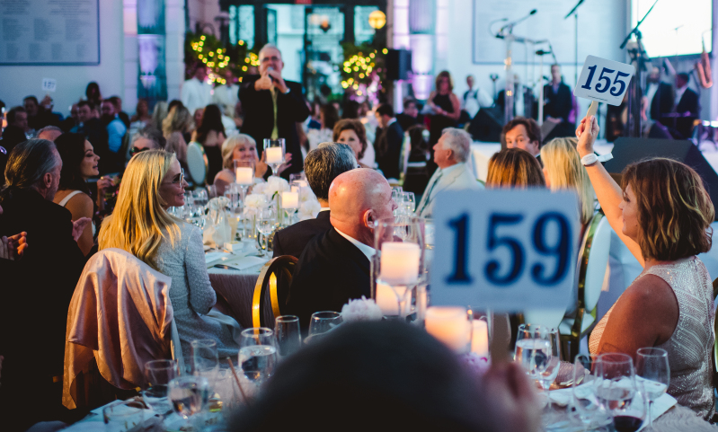

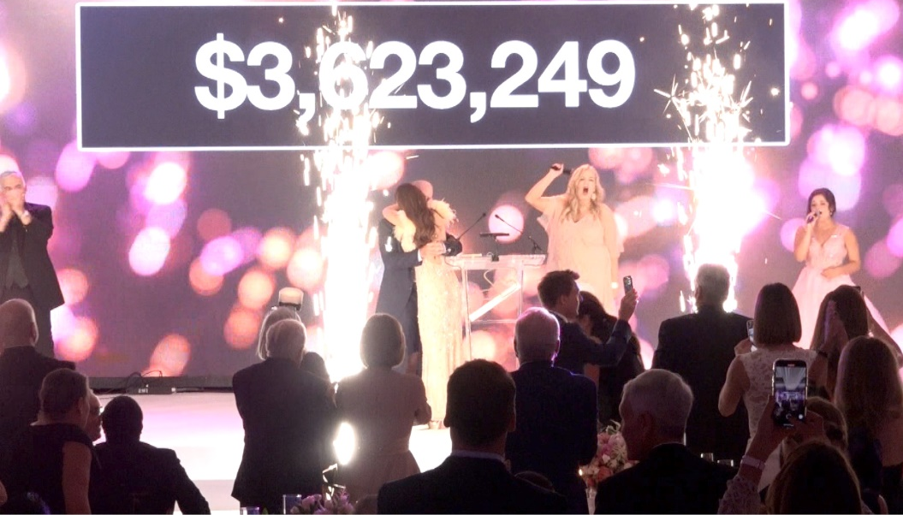

- Immokalee Foundation
Scott Robertson Auctioneers, now Champion Fundraising Auctions, has worked with The Immokalee Foundation for years in raising funds to support their goals for education, health care, and career development programs. Each year the event features some of the children impacted by this charity’s good work, which always brings the crow to their feet. To date, Champion Fundraising Auctions with Scott Robertson has helped Immokalee Foundation raise millions of dollars for their cause.

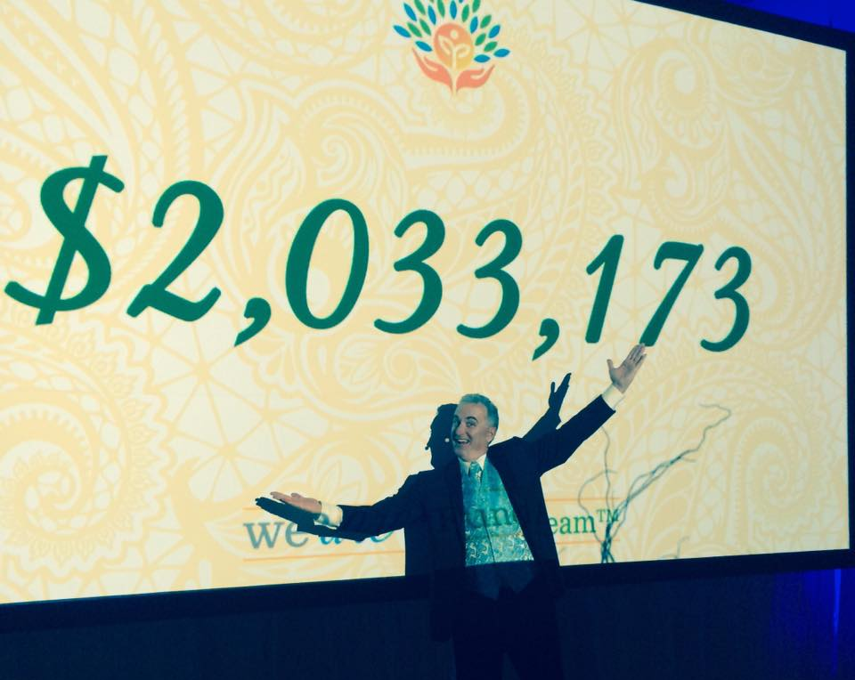
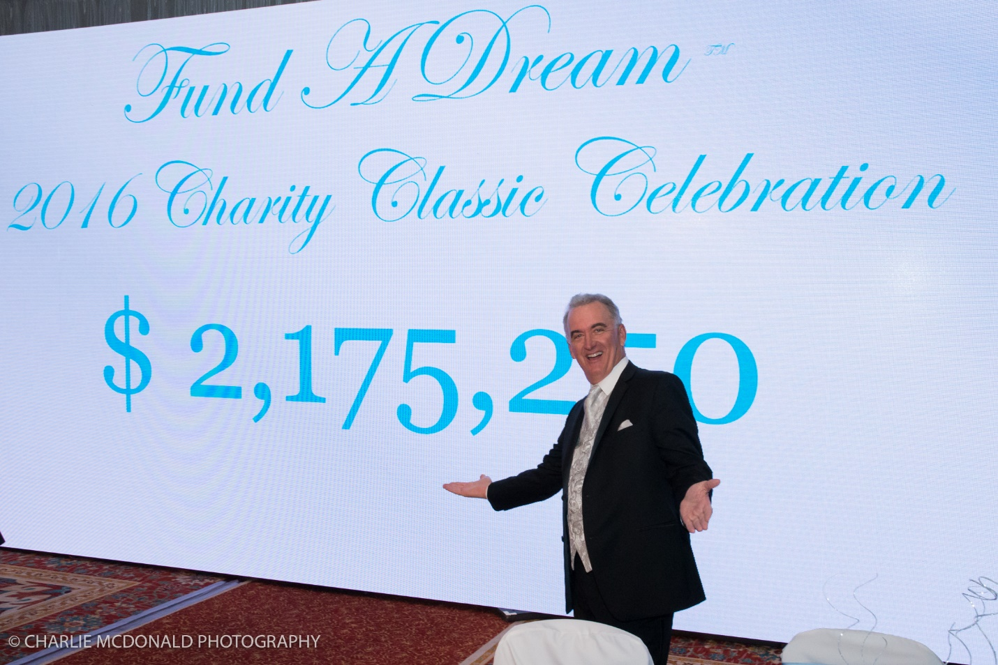

3.Naples Senior Center
Scott Robertson has had the pleasure to be the Ambassador of giving at the annual fundraising event for Naples Senior Center for several years, The organization provides programs and services for seniors that include dementia respite support, geriatric case management, mental health services and a food pantry. Each year, Scott is amazed by the generosity of the community as they come together to raise funds for this worthy cause. View some event highlights here!

